**Weekly Report 11 & 12**

Date:

## Implementation Details

**Code :**

GUI :

# Recommendation functions

def get_user_based_recommendations(user_id, num_recommendations=5):

try:

# Create user-destination matrix

user_dest_matrix = userhistory_df.pivot_table(

index='UserID',

columns='DestinationID',

values='ExperienceRating',

fill_value=0

)

# Calculate cosine similarity between users

user_similarity = cosine_similarity(user_dest_matrix)

user_similarity_df = pd.DataFrame(

user_similarity,

index=user_dest_matrix.index,

columns=user_dest_matrix.index

)

# Get similar users (excluding the user themselves)

similar_users = user_similarity_df[user_id].sort_values(ascending=False)[1:6].index

# Get destinations rated highly by similar users

similar_users_ratings = user_dest_matrix.loc[similar_users]

avg_ratings = similar_users_ratings.mean(axis=0)

# Filter out destinations already visited by the user

visited_destinations = userhistory_df[userhistory_df['UserID'] == user_id]['DestinationID'].unique()

recommendations = avg_ratings[~avg_ratings.index.isin(visited_destinations)]

recommendations = recommendations.sort_values(ascending=False).head(num_recommendations)

return recommendations.index.tolist()

except Exception as e:

st.error(f"Error in recommendation generation: {str(e)}")

return []

def get_popular_recommendations(num_recommendations=5):

return destinations_df.sort_values('Popularity', ascending=False)['DestinationID'].head(num_recommendations).tolist()

def get_content_based_recommendations(destination_id, num_recommendations=5):

try:

# Vectorize destination features

vectorizer = CountVectorizer()

features = destinations_df['Type'] + ' ' + destinations_df['State'] + ' ' + destinations_df['BestTimeToVisit']

feature_matrix = vectorizer.fit_transform(features)

# Calculate cosine similarity between destinations

similarity_matrix = cosine_similarity(feature_matrix)

# Get similar destinations

destination_idx = destinations_df[destinations_df['DestinationID'] == destination_id].index[0]

similar_destinations = list(enumerate(similarity_matrix[destination_idx]))

similar_destinations = sorted(similar_destinations, key=lambda x: x[1], reverse=True)[1:num_recommendations+1]

return [destinations_df.iloc[i[0]]['DestinationID'] for i in similar_destinations]

except Exception as e:

st.error(f"Error in content-based recommendations: {str(e)}")

return []

Data Cleaning :

def recommend_destinations(user_id, userhistory_df, destinations_df, cosine_sim):

"""

Recommends top 5 destinations for a given user based on similarity scores.

Args:

- user_id: ID of the user.

- userhistory_df: User history DataFrame containing 'UserID' and 'DestinationID'.

- destinations_df: Destinations DataFrame containing destination details.

- cosine_sim: Cosine similarity matrix for destinations.

Returns:

- DataFrame with recommended destinations and their details.

"""

# Get the destinations the user has visited

visited_destinations = userhistory_df[userhistory_df['UserID'] == user_id]['DestinationID'].values

# Calculate similarity scores for visited destinations

similar_scores = np.sum(cosine_sim[visited_destinations - 1], axis=0)

# Recommend the top 5 destinations the user hasn't visited yet

recommended_destinations_idx = np.argsort(similar_scores)[::-1]

recommendations = []

for idx in recommended_destinations_idx:

if destinations_df.iloc[idx]['DestinationID'] not in visited_destinations:

# Append detailed information for each recommendation

recommendations.append(destinations_df.iloc[idx][[

'DestinationID', 'Name', 'State', 'Type', 'Popularity', 'BestTimeToVisit'

]].to_dict())

if len(recommendations) >= 100:

break

# Convert recommendations to a DataFrame

return pd.DataFrame(recommendations)

# Example: Recommend destinations for user with ID 1

recommended_destinations = recommend_destinations(5, userhistory_df, destinations_df, cosine_sim)

# Display recommendations

recommended_destinationsata

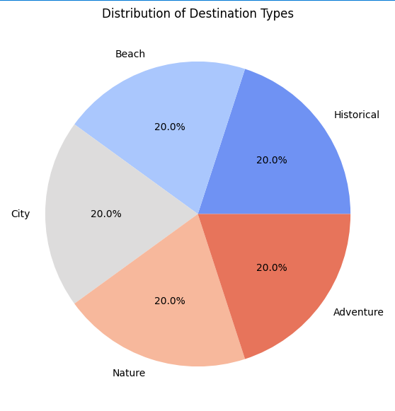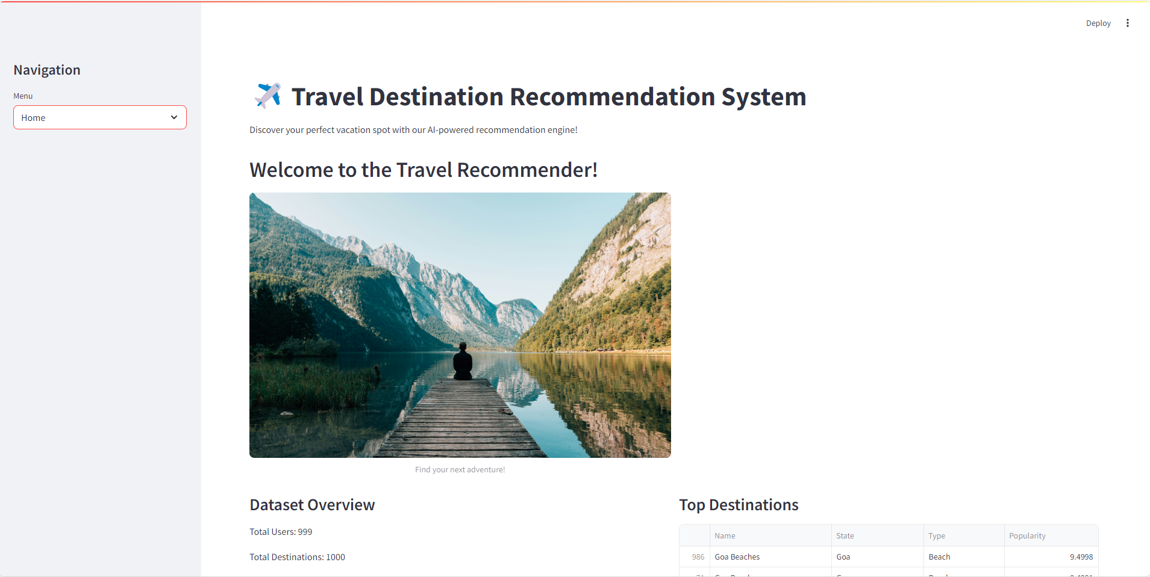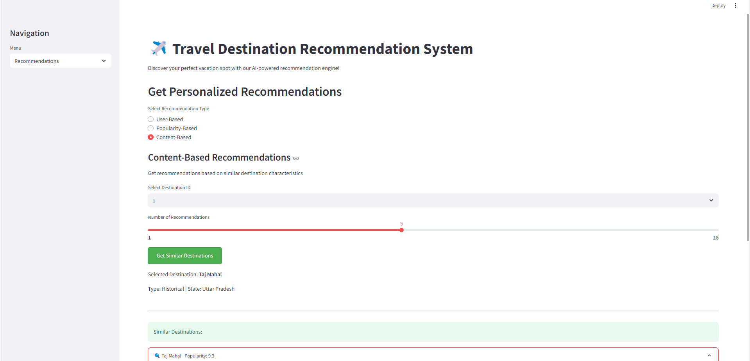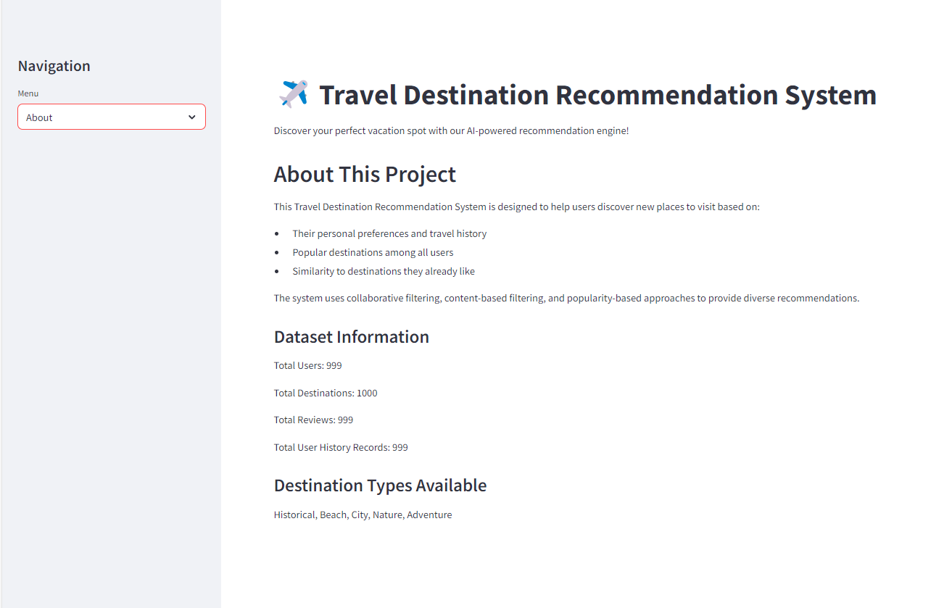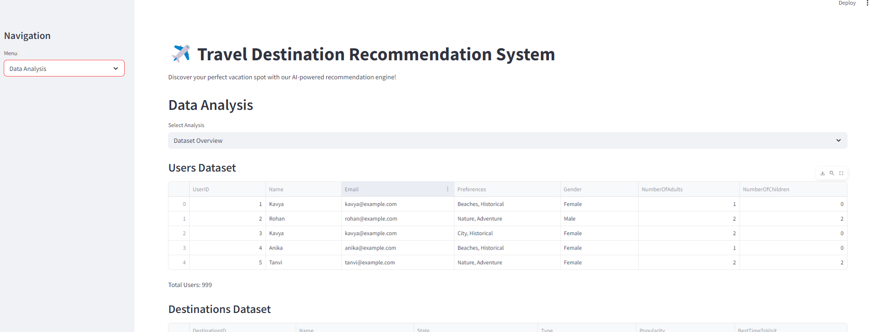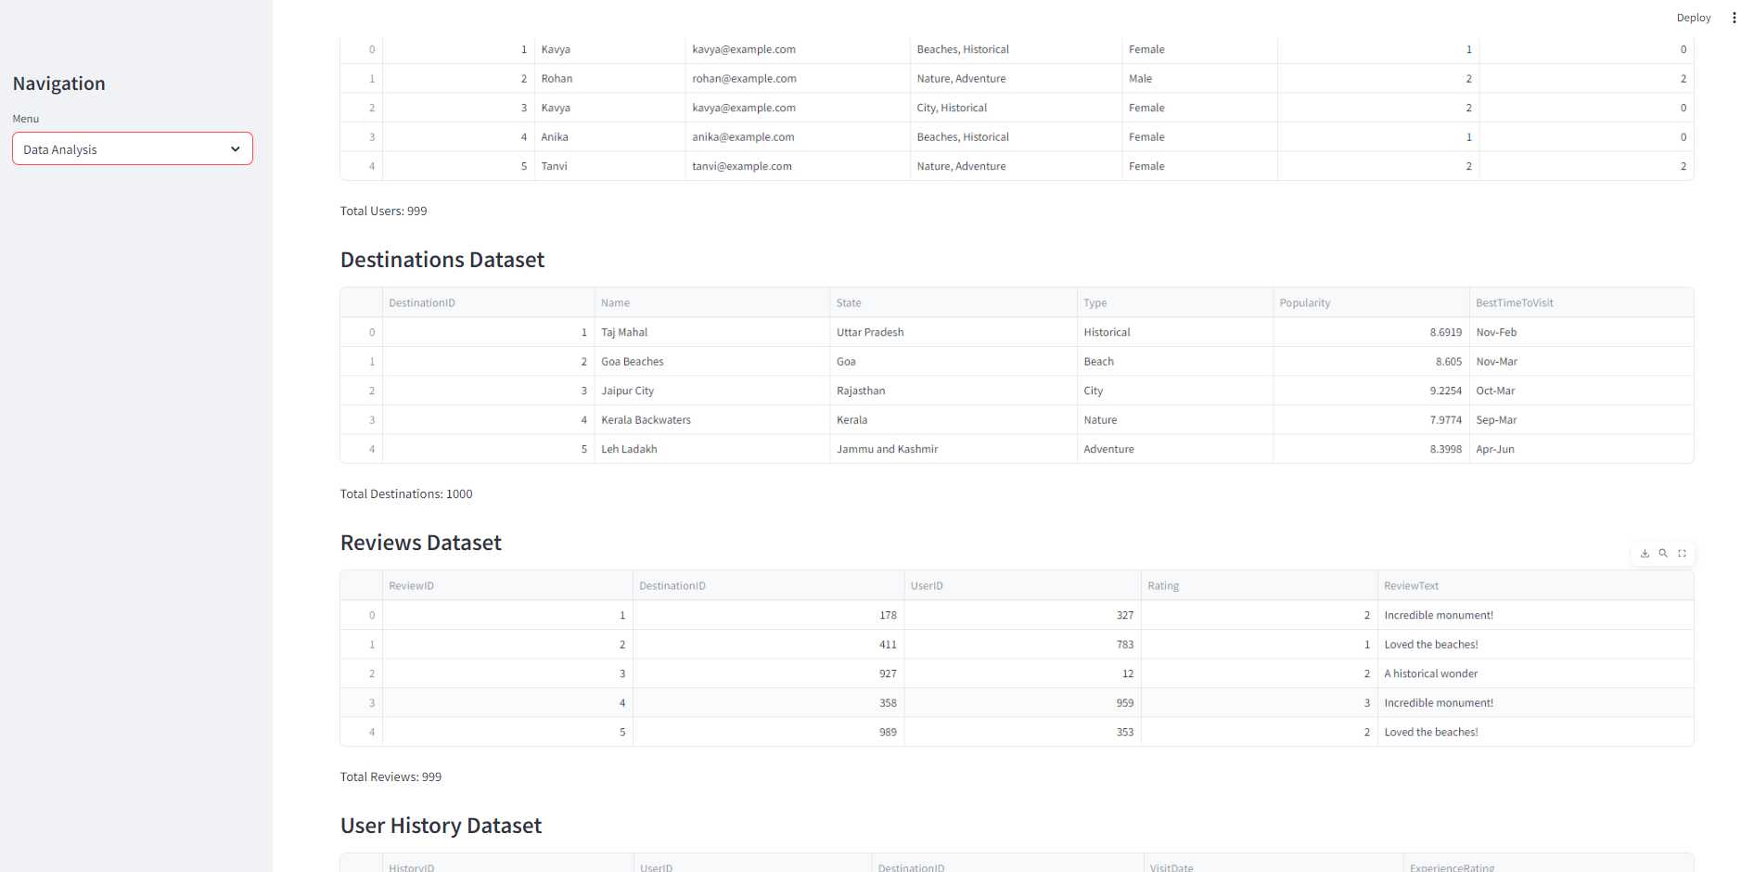

Submitted By-  
Gauri Uday Gotad (23030421995506)

Sign of Faculty Incharge